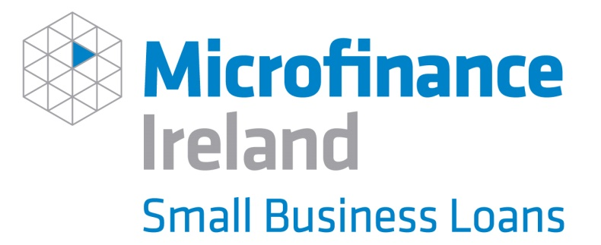

Microfinance Ireland (MFI), is a not-for-profit lender, established to deliver the Government’s Microenterprise Loan Fund.
MFI works very closely with the Local Enterprise Offices (LEOs), providing loans to small businesses. Helping to create and sustain employment by providing loans to small businesses is at the heart of what they do.
MFI works with small businesses based in the Republic of Ireland, with fewer than 10 employees and turnover up to €2m, by providing unsecured business loans of €2,000 to €25,000 for commercially viable proposals. Loans can be used to fund start-up costs, working capital, purchase of stock, equipment, machinery, business expansion etc.
They consider applications from businesses who may have been declined facilities from other commercial providers
Whether your business is set up as a Sole Trader, Partnership or a Limited Company, you are eligible to apply. All business sectors are eligible to apply, with these exceptions:

You can apply for an MFI loan through your Local Enterprise Office and avail of a 1% discount off the standard interest rate (currently 7.8% APR) bringing the rate to 6.8% APR.

Once a customer has been approved a loan with MFI, mentoring support will be provided with a mentor from the LEO Mentor Panel. Mentoring is a critically important non-financial learning and support tool, helping business develop and grow.

Calculate your monthly repayments using MFI’s Loan Calculator

To make a loan application, you will need to complete and submit a number of documents as part of the application process. Talk to your LEO Business Advisor or Click here for more information.

