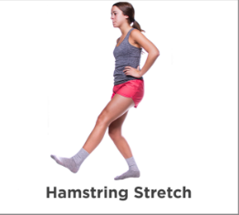
Hamstring Stretch
You should feel this stretch at the back of your thighs and behind your knees.
Sit up tall with both legs extended straight in front of you. Your feet are neutral — not pointed or flexed. Place your palms on the floor and slide your hands toward your ankles. Hold for 30 seconds.
Do: Keep your chest open and back long. Reach from your hips. Stop sliding your palms forward when you feel the stretch.
Do not: Round your back or try to bring your nose to your knees. Do not lock your knees.
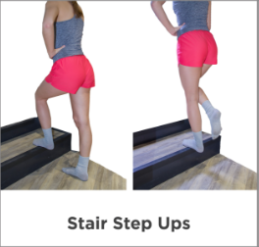
Stair Step Ups
You should feel this exercise in the front and back of your thigh, your hip, and buttocks.
Use a 6-inch high stool or platform. Step one foot onto the platform. Lift your other foot off the floor, letting it hang loosely off the platform. Try to hold for 3 to 5 seconds. Slowly lower your hanging foot to the floor, then bring your stepping foot down. Repeat and switch sides.
Do: Make sure when you step up that your whole foot is on the platform.
Do not: Lock the knee that is stepping on the platform.
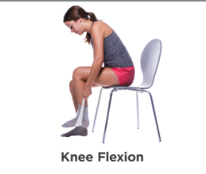
Chair knee extension:
You should feel this exercise mostly in the front of your thigh.
Sitting in a chair, rest your foot on the floor. Gently raise the foot toward the ceiling using only leg muscles. Hold for 5 - 10 seconds and release. Repeat 5 times on each leg.
Do: Keep your upper body relaxed and tighten your stomach muscles to keep your low back flat against the floor.
Do not: Arch your back. Do not lift your leg too high with a jerking motion

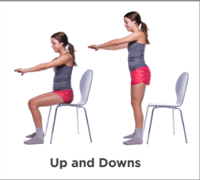
Up and Downs:
Sit in a firm, arm less chair with your feet flat on the ground. Slowly stand up (without using your hands) using deliberate, controlled movements, until you reach your full height. Hold for a few seconds, and then slowly sit down again. Repeat this exercise for about 1 minute. A firm cushion can be placed on the chair if this move is difficult at first. Tip: Check your knees — when going up or down, they should never move forward beyond your toes. Also try to keep your knees pointed forward, avoid pointing them inwards or outwards. This knee pain remedy will do wonders!
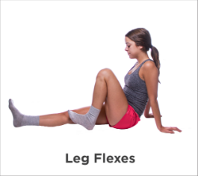
Leg Flexes:
This is one of the best exercises for knee pain! Sit on the floor with your legs together and extended out in front of you. Place your hands on the floor behind you for support. Slowly bend your left knee, slide your heel along the floor toward your body until you feel a gentle stretch in the thigh muscles. Hold for about 5 seconds, and then slide your foot forward, still on the floor, straightening your leg. Rest a few seconds. Do 10 times. Change legs, and repeat 10 times.
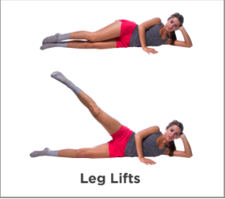
Leg Lifts:
Our last natural remedy for knee pain has you lie on your right side, either on cushy carpet or an exercise mat. Use your right hand to support your head and your left hand to steady your balance. Keeping your legs straight, slowly lift your top leg straight up, as far as you comfortably can. Hold for a few seconds, and then slowly lower the leg. Do 10 times; switch sides and repeat. Slow, controlled movements will bring the most benefit.

